KIDS WORLD
RED HILLS CHURCH

children’s ministry guide 2017-18

table of contents

WHO WE ARE
welcome 2
our purpose & process 3
relational ministry & values 4
wins for Kids World 5

OPERATIONS
serving commitment 6
leaders 7
equipping 8
goals 9
checking in 10
sick kids/checking out 11
classroom management 12
discipline 13

SAFETY
physical touch 14
ratios 15
injuries 16
emergencies 17-19

FIVE MINISTRIES
wigglers & waddlers 20-21
twos and threes 22-23
fours & fives (not in kindergarten) 24-25
kindergarten & 1st grade 24-25
2nd – 5th grade 26-27

LEADERSHIP
teams 28-29
the commitment 31
joining the team 32
notes 33-34
forms 35-40

welcome
Hello! Thanks for picking up our Kids World Children’s Ministry Guide!
Whether you’re just thinking about serving in Kids World or you’ve been serving for a hundred years, the goal of this guide is the same:
- To inspire you. Give you vision for why kids ministry is vital!
- To equip you. Give you the key tools and info to be an effective leader.
- To empower you. Give you the reigns to go and do ministry.
We believe that God wants our best as we serve our kids, and we have a lot of lofty goals we’re trying to meet as we minister to our young ones. If we were merely trying to babysit kids, we wouldn’t bother with a guide like this. But Kids World is more than babysitting - it’s raising up the next generation. We hope you’ll join us!

WITH great children’s ministry
WITHOUT great children’s ministry

If you have any questions or ideas that go beyond what’s written in here, give me a call or shoot me an email. I’m so glad you want to join our Kids World team!
Teacher Kim

Kim Lopez
Children’s Pastor
teacherkim@redhills.church
503.538.6525 ex103
503.516.6199

our purpose
Kids World exists to train up the next generation to…
LOVE GOD Matthew 22:36 Great Commandment
LOVE PEOPLE Matthew 22:37 Great Commandment
SERVE THE WORLD Matthew 28:19 Great Commission

our process

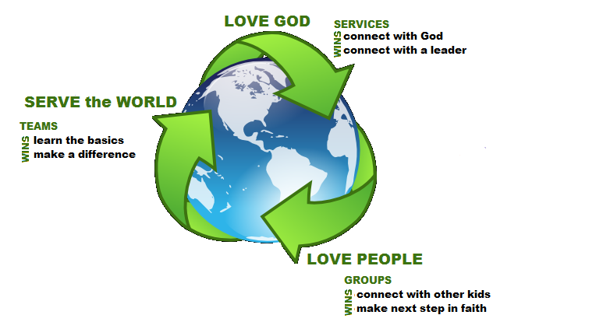

relational ministry
The FOUNDATION of this ministry is relationships. That is, caring leaders who go out of their way to express Christ’s love to kids. Our ministry is designed around this principle. Relational ministry is the CATALYST that propels a kid to experience and develop God’s purposes in their life.
Here’s how it works: A kid won’t remember creative Bible studies, crazy events, or a carefully crafted talk. What they will remember is YOU! They won’t forget the leader who LIKED THEM and LOVED GOD. The leader that talked to them when no one else would, who went into their world, who was there for them when family life got tough. You’re the practical means in which a kid will experience Christ’s love.

relational values
These are the four values that every Kids World teacher must strive to CONSISTENTLY embody:
1) SHOW UP Kids make spiritual decisions in the context of relationship. We only have a small window of time together to develop those… so your presence matters! Show up faithfully and don’t be rushed. Look kids in the eyes and give them the attention they deserve.
2) SHOW INTEREST Take an honest interest in the kids: Learn names, ask good questions, get to know someone’s likes/dislikes. Children love to talk about themselves. So don’t stop at their name. Come down to their level and really connect with them. Remember their parents’ names, even their pet’s. Get to know others – it’s the easiest way to make a big church feel small. Any person who comes into contact with you should look forward to the next time they bump into you.
3) SHOW LOVE God has enabled us with various ways to show kids we care about them, so let’s put them to use. This goes beyond showing interest, friendly handshakes, or high-fives. Say something really encouraging to them or talk-them-up in front of other kids or their parents. Trust the Holy Spirit to guide you in how to best communicate care and show outlandish love to kids.
4) POINT THEM FORWARD Point out a kid’s potential. Encourage kids to take the next step in their faith journey. Help them see how their strengths and abilities can be used to make a Kingdom impact. Become a personal cheerleader when they win, and a travel guide that points them forward to Christ and His purposes.

wins for Kids World
The vision of Kids World is to help parents build Christ-centered families so that kids grow up loving God, loving people, and serving the world. This translates into three “wins” for us. We win when kids know Jesus, when kids know others, and when parents know how to lead.

When kids know JESUS.
Whether we’re talking about a baby or a 5th grader, kids must in some way experience the love of God through His Son, Jesus, or we’ve missed the mark. Kids experience Jesus when they hear about him, sing about him, see the reality of him in you, and when they feel Jesus tugging at their own hearts.

When kids know OTHERS.
From the Wigglers to 5th Grade, we want every child to have a positive connection with other kids and leaders while they’re in Kids World. If a kid comes and doesn’t connect in a meaningful way with other kids their age and teachers, we’ve missed the mark. For kids to know other kids and you, we’ve got to build a fun and meaning-filled environment where they can connect naturally.
When parents know how to LEAD.
We are a “family empowering” ministry, so we do not support the “drop your kids off with us and we’ll fix them” mentality. We want and expect all parents to help out and lead the charge in ministering to kids. We win when they feel equipped to do so.
We only win when all 3 of these wins are balanced.
.

operations: serving commitment
When you apply to volunteer in Kids World, we assume you can be with us for at least 12 months (9 months for college students who may leave during the summer). Relationships with the kids and families are important, so the longer you can be with an age group, the kids get to know you and you get to know them and – BOOM – relationships!
Here is how this commitment affects you as a Kids World volunteer:
TRAINING
We will have one or two trainings a year. Trainings are required because we want you to feel informed and equipped. The method of training we use varies from season to season, but the idea remains the same: we need everyone on the same page, connect as a team, and be ready to love and serve kids for the upcoming year. Trainings are a priority in Kids World, both for safety and quality. Also, we highly encourage you to attend our volunteer appreciation event with your team. All Kids World ministries will be combined.
SERVING
In Kids World, we are focusing on the long-term; not the short-term. This will allow you ample time to build great relationships with kids and families. If you serve in an area that does not seem to be a good fit, please talk to the ministry leader right away. Every fall we will connect with you to see how things are going with you. If you need to step down or transition to another area, May and September are the best time to do this. Our goal is to get you to see how fun and rewarding it is to serve the children in Kids World. When it’s fun and rewarding, kids and families will be served well.
COMMUNICATING
New job, life change, need a break… email, call, text, or carrier pigeon. Let us know about what’s going on! Life happens. You won’t hurt our feelings. Use Planning Center Online (more about that later) to block out dates you already know you’ll be unavailable. This helps our schedulers so much it’s crazy! Would like to serve more or on a different week? Fabulous! Kim’s contact information is on the first page of this manual for your convenience.

operations: leaders
VALUE OF LEADERS
It talks over 150 leaders to operate Kids World. We have a great team, but the heart and soul of Kids World is you, the teacher. You teachers have more influence than you think. And here are the steps to help you have influence in Kids World.
Be a LEADER WHO…
GIVES GRACE
We have kids in Kids World from a variety of different backgrounds and experiences. You do not know all that is going on in a kid’s life. Let’s be grace givers while still giving healthy boundaries when necessary.
SPEAKS LIFE
Always look for the positive to point out in kids. Take it a step further and tell the parent that positive attribute or action. What parent doesn’t want to hear positive things about their kids?
COMES TO THEIR LEVEL
Don’t speak down to kids, but bend a knee and come to their level. Try to see life through their eyes and amazing imaginations.
CONNECTS WITH PARENTS
We aren’t just serving kids - we are serving families. Use every opportunity to connect with parents and start building relationship.
FOCUSES ON THE KIDS
The curriculum may not work just as we/you planned, or something else might happen that requires you and other leaders to be flexible as you serve. Remember that we are all about the kids. Let’s make sure they are the priority!

operations: equipping
We want Kids World to be the best it can possibly be. We know you’re a smart, good-looking person, but all of us have room to improve in serving kids even better! We do this through…
TRAINING
All leaders are required to attend trainings. It’s not just because we want to get info about curriculum, program updates and other news to you. A huge part of it is to simply be together as a team, to eat together, and to realize that we are all this together. It’s a vital time for us to connect. Childcare will be provided.
VIDEO TRAINING
During the year we’ll post video trainings and we’ll ask you to watch them. The videos will be accessible online at redhills.church under the Kids World page and on Planning Center Online.
SCHEDULING EMAILS from PLANNING CENTER ONLINE
Every month you’ll receive a scheduling email from Planning Center Online with time(s) you are scheduled to serve. We need everyone to read each email and respond – taking less than 5 minutes. Lessons can be downloaded from the service page and/or they will be provided for you. Again, it’s vital the entire team is on the same page.
SUNDAY HUDDLES
Each Sunday, there is a huddle in your specific area that you serve. This is a key time to hear info from your lead teacher, connect with the team, and pray over the kids and families coming to church that specific day. Please make every effort to be at these on time.
REPRODUCING YOURSELF
What if everyone reproduced themselves in another person? Think about how many more kids and families we would be able to impact. We want you to reproduce yourself in whatever role you’re in using a model similar to this:
- I do and you watch.
- I do and you help.
- You do and I help.
- You do and I applaud.

operations: goals
Kids World - FAMILY MINISTRY ESSENTIALS

Empowering Family as Primary God’s design for faith replication is through the context of the family (Deut. 6; Ps. 78). The church plays a supportive/equipping role in this endeavor and fills in the gap for family when sin, spiritual blindness, and/or dysfunction keep a physical family from being the spiritual leader (Eph. 4:12).

Spiritual Formation for Lifetime Faith A new generation needs a strong foundation of biblical knowledge in an environment where they can encounter the living God. Children and students can open their hearts to God, learn to discern His voice, have a desire to obey Him, and do so in the power of the Holy Spirit (Phil. 2:13).

Scripture is Our Authority The Bible is God’s truth for daily living. God’s Word holds instruction and inspiration that guides children and students to know God and interpret their lives through the lens of His character and perfect will (2 Tim. 3:16-17).

The Holy Spirit Teaches Parents and leaders have the opportunity to create “environments” where the Holy Spirit is free to move, teach, and lead through His Word and other believers (Jn. 14:26).

God is Central Because it is one story the emphasis is on God’s love and redemption through Jesus (Col. 1:20), not the supporting cast in any given storyline (for example: “God is Victorious” vs. “David and Goliath”). God is central to His Word, our lives, and the gospel.

A Community of Ministry Support First, the Holy Spirit comes alongside of each believer to support him/her in living as a disciple of Christ. Next, a unified community of ministry leaders from around the globe inspires, equips, and supports each other to transform the lives of a new generation both in the church and in the home so that no one is alone in the endeavor to pass on faith to the following generation (I Cor. 12:18-27).

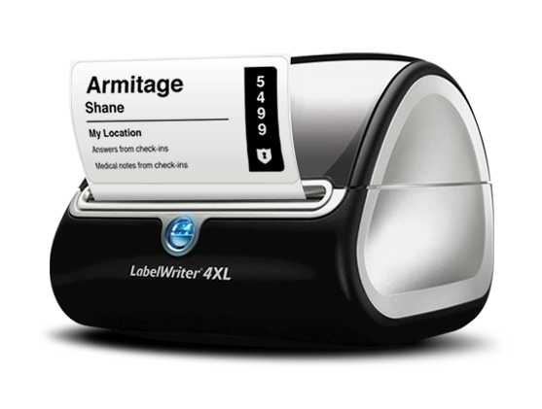
operations: checking-in
Here’s HOW check-in works:
EVERY HUMAN CHECKS IN
Every kid and leader in Kids World needs to be wearing a Kids World volunteer name tag with the area on it they are serving in. Kids World teachers also must be wearing their Kids World t-shirt. If an individual is in a room and they aren’t checked in, speak up!
NEW FAMILIES CHECK IN AT KIDS WORLD INFO COUNTER
If anyone looks new (or smells new), please take them to the Kids World Info Counter and they will be greeted by our Welcome Check-in Team.
THERE ARE 3 CHECK-IN LOCATIONS
They will get their tags at one of these locations, then go to the room(s).
- two self-check stations upstairs and one downstairs
- Each classroom has a computer for check out. Please only check out the child in your classroom.
2 TAGS ARE NEEDED AT DROP-OFF
Tag 1: The parents should keep their “pick-up tag” which has a big 6-digit code on it.
Tag 2: The kid should be wearing a nametag.
NOTIFYING PARENTS
Because there may be a need for a parent to return early to the classroom to assist with their child, please make sure we have an accurate phone number and let parents know at drop off to leave their cell phones on vibrate during service in case we need to contact them. If the parent doesn’t arrive, let Teacher Kim know and she will notify the sound booth team to put a notice up on the sanctuary screen.
IF KIDS WORLD COMPUTER IS “DOWN”
This may happen a couple times per year. And this is what we want to see: We’ll use the cards we used before the new system. We will handwrite name tags. The parent will get a number card and we will use a clipboard sign-in. The parent will use the Kids World when they return to pick up their child.

operations: sick kids
WE ONLY CHECK IN HEALTHY KIDS
To avoid getting several other kids/babies sick, we will only accept children who appear to be healthy (no colds, flu, etc). If the parent says their kid is sick, apologize, but please don’t check them in.
OPTIONS WITH SICK KIDS
If a child or baby is sick in any way, we will ask parents to sit in the
auditorium or Café area. If this won’t work, going home and taking the week off is what we’ll recommend.

operations: checking out
PARENTS MUST PRESENT THE “PICKUP TAG”
To keep security buckled down we ask EVERY parent for their tag. If the person trying to pick up a child doesn’t have the proper tag, call Teacher Kim or someone on staff. Also, they can show you a picture of the code on their phone or a government-issued photo ID. We scan every child out.
PARENTS CAN CHECK KIDS OUT AT ANY TIME
Parents can also check their kid out at any point in the service. We love giving kids back to parents! If there’s a fire alarm and we all evacuate, parents can present their pickup tag and take their kid home if they want. Third & Grant will be where the Nursery, Twos & Threes, Fours & Fives and 2nd -5th Grade classes will be, and the Kindergarten 1st Grade class will be at Second & Grant intersection.
TRY TO MAKE CHECK-OUT PROMPT
Kids will oftentimes stall and try to finish the game they’re playing. Parents are eager to hit the road, so feel free to go put your hand on their shoulder and help them get moving toward their parents.

operations: classroom management
DON’T BE OVERWHELMED
Just stick with the curriculum and do your best. They’re kids! And you’re your own biggest critic. Just keep trying to love and lead them.
BE CLEAR
Don’t let kid guess what they should be doing. That’s when things get chaotic! Be clear in communicating your expectations. Lead them with clarity and healthy boundaries.
WORK TOGETHER
You’re not the only leader in the room. Work with the other teachers/volunteers in the room. Come up with a plan together as a team.
DIVIDE AND CONQUER
Split rowdy kids apart, with each leader taking one (if needed). If two kids can’t co-exist, roll with it! Get them to different areas.
MAKE IT FUN
Be goofy, be likeable, have a great time so kids will relax and want to follow your lead. Most of our kids are great and very seldom act out when they’re having fun.

operations: discipline
Keep in mind that kids who are misbehaving or “acting out” likely have a reason for it – a reason that you likely don’t know about. “Love covers a multitude of sins!” So that’s always our go-to disciplinary action: Lay on some love before trying anything else.
DISCIPLINE “DO NOTS”
- Striking a child in any way
- Raising your hand at a child
- Yelling at a child (unless they’re about to be hit by a train)
- Threatening a child
- Speaking hurtful words to a child, parent, or another leader
- Grabbing the child’s arm or wrist firmly
DISCIPLINE “DO’S”
- Give them their options
Give 2 options, both of which you’ll be happy with. “Hey Johnny, you can either use kind words or you can sit by yourself. What’s your choice?” If they don’t choose one, then you get to choose for them.

- Change the situation
If the issue isn’t solved by offering a choice, or if something happens again, change their situation: remove them from their friends or from a fun activity, have them sit near you, etc. Tell them they can return when they’re ready to play by the house rules.

- Contact Lead Teacher or the Children’s Pastor
If another round of 1 and 2 doesn’t work, go ahead and get lead teacher or children’s pastor to call/text their parents. They don’t have to pick up their child; a pep-talk might be enough. But don’t be afraid to get the parents involved.

C.O.O.L. Rules
Care about your neighbor
Only talk or get up if you raise your hand
Obey the teacher
Let’s get ready to have fun!

safety: physical touch
TOUCH STANDARDS
The GOOD means we encourage these positive and safe ways to show love. Do them!
The BAD means please avoid these ways of showing love, for the safety of all.
The UGLY means we don’t allow anyone to do it, even you. Doing it might mean removing you from the team.
0-2 year olds:
GOOD: hugs, carrying, holding
BAD: Kisses, extended length of touching
UGLY: Being alone with them, men changing diapers, spanking, threatening to spank
3-10 year olds:
GOOD: high fives, handshakes, brief side-hugs
BAD: kids on your lap, extended length of touching
UGLY: Being alone with them, any touch between shoulder and knee, spanking, threatening to spank

safety: ratios
LEADER-TO-CHILD RATIO
Safety is always our number one priority. There must always be 2 leaders in the room – no exceptions.
If a parent wishes to stay with their child in the room, give them options and invite them stay with their own child - make sure the parents get a “Visitor” tag or Teacher Badge. Invite them to be a part of our children’s ministry and help serve. Parents or anyone serving must have a background check on file with Red Hills Church.
DISCOVER
Wigglers/Waddlers: 1:1 – 1:5
1 adult per infant
1 adult per 3 one-year-olds
(Teachers must be 12 years old to serve in the Wigglers Nursery.)

Twos and Threes: 1:5
1 teacher per 5 two-year-olds/three-year-olds

ADVENTURE
Fours & Fives -- 1:7
1 adult per 7 kids

Kindergarten & 1st Grade: 1:7
1 adult per 7 kids

2nd and 5th Grade – 1:9
1 adult per 9 kids

safety: injuries
If a kid is only KINDA HURT
Scraped knee/elbow, bumped head, bloody lip, hurt feelings…
BAND-AID AND A PRAYER: Most incidents are small and can be handled this easily. Get on their level, show them some compassion, and get their mind back on track as fast as possible.
WHAT NOT TO DO: Don’t make a bigger deal than it is. Don’t scare the other kids! Don’t pull the fire alarm or scream uncontrollably.

If a kid is HURT BADLY
Head injury, broken bones, unconscious, losing blood, etc.
KEEP EVERYONE CALM: Don’t move the child unless they’re in danger. Assure them they’ll be ok.
SEND FOR TEACHER KIM OR SERVICE COORDINATOR: Don’t leave the child. Send someone else to get Teacher Kim, service coordinator or any of the staff.
MAKE THE CALL: If it’s serious, call 911. If you’re unsure, let a staff member make the call. Walkie-talkies are located in each classroom and with service coordinators.
OTHER LEADERS SHOULD: Pray for the child with the other students. Explain what’s happening and answer questions. Try to transition them away from the incident and back into the morning’s activities.
INJURY REPORT: There should be an incident response form in the “staff only” closet. Fill out every area for our records. Turn the form into the service coordinator.
ANY TIME THERE’S BLOOD: We use “universal precautions”. This means if there is any amount of bodily fluid (blood!), you use a protective barrier, like latex gloves. Always.

safety: emergencies
ALL EVACUATIONS
GATHER YOUR KIDS: Teachers are responsible for getting all the children in a line and exiting the classroom in an orderly manner. Have all the children line up and do a head count before exiting. One teacher from each class must bring the sign-in sheet or computer.
GO TO THE Corner of Third & Grant (children safe zone): After arriving to safety do another head count and double check against the sign-in sheet. Establish a checkout procedure which ensures that each child is accounted for. Do not re-enter the building without approval from fire/police personnel or church staff.
PARENT PICK UP: Parents are NOT allowed to take their children away from the group until a checkout procedure has been established. This is the best way to ensure all children are accounted for.

EARTHQUAKES
BE THEIR MODEL: Keep everyone calm. Say “Everyone do like me… get under a table.” If you freak out, they’ll freak out. So just keep it together, man!
DROP, COVER, STAY: If you’re in a room with desks or tables, get under them. If there are none, get away from the windows and close a wall, drop down and cover your head, and stay there until the shaking is totally stopped.
MOVE TO SAFE ZONE: Once the shaking stops, evacuate the building per the instructions above.

safety: emergencies
LOCKDOWN
A lockdown is used when a violent, life-threatening person is on church property or suspected of being on church property. The purpose of a lockdown is to hide as many individuals behind locked doors in as little time as possible. The key to remembering what to do in a lockdown is “locks, lights, out-of-sight!” A lockdown will be communicated by use of walkie-talkies. When a lockdown is communicated:
- Secure children and volunteers inside a classroom, bathroom, or closet.
- Move into internal rooms if available. This creates additional distance and protective barriers from the threat.
- Lock all doors and windows within the room.
- Turn off lights. Remain quiet. Hide in a safe place out of the line of sight from the hallway doors or windows. Sit/lay on the floor. Exterior walls are best if out of line of sight and further away from the threat. Under a window is okay if necessary. It is vital that you are familiar with your surroundings and are able to act quickly and decisively in the event of a lock down.
WIGGLERS: Hide under counter

WADDLERS: Hide under counter and close blinds.

PRE+K and TWOS & THREES: Go into the bathroom and lock both doors.
1ST - 5TH GRADE: Cover back door window, go to back wall by computer or under tables.
- If the fire alarm goes off, do not evacuate unless a threat is imminent.
- Notify 911 and turn off or silence all cell phones.
- Do not open the locked door for anyone. Only church staff, service coordinators or law enforcement have the authority to release the lockdown- they will have keys to unlock the doors. When the lockdown is released church staff, service coordinators or law enforcement will unlock the doors and provide further instructions. Remember, children are not to be released to their parents until a check-out procedure has been established.

safety: emergencies
MISSING CHILD
Parents place a great deal of trust in us, allowing us to care for, teach and disciple their children. Our highest priority is to be worthy of that trust. We must be vigilant at all times. This is especially important during the high-risk times: check-in and -out and times of transition. Performing head counts, double-checking the check-in printout, using our eyes and ears to monitor the room.
If the unthinkable happens and a child is missing from a classroom, it is the responsibility of the teacher to initiate a Missing Child Response:
This is communicated to all Kids World volunteers and the Service Coordinator. Communication will include the child's name, physical appearance, when and where they were last seen.
The immediate response is to lockdown all church buildings - no one may leave or enter any church building or classroom until a procedure is established.
KIDS WORLD RESPONSIBILITIES
Do not allow anyone to leave. Search the classroom. The children’s pastor or coordinator will set up a check out procedure and will keep you informed of next steps.

CHURCH STAFF RESPONSIBILITIES
Assign three people to lockdown the two exterior doors in the sanctuary and the front door. No one may leave the building until a check out procedure has been established. Assign two to three people to search the church buildings and exterior surroundings.

CALLING 911
911 will be called no more than 10 minutes after the Missing Child Response is initiated. 911 may be called sooner if deemed necessary. The children’s pastor or coordinator will call or designate someone else to call 911. After the call is place all staff and volunteers will follow the directions of law enforcement personnel.

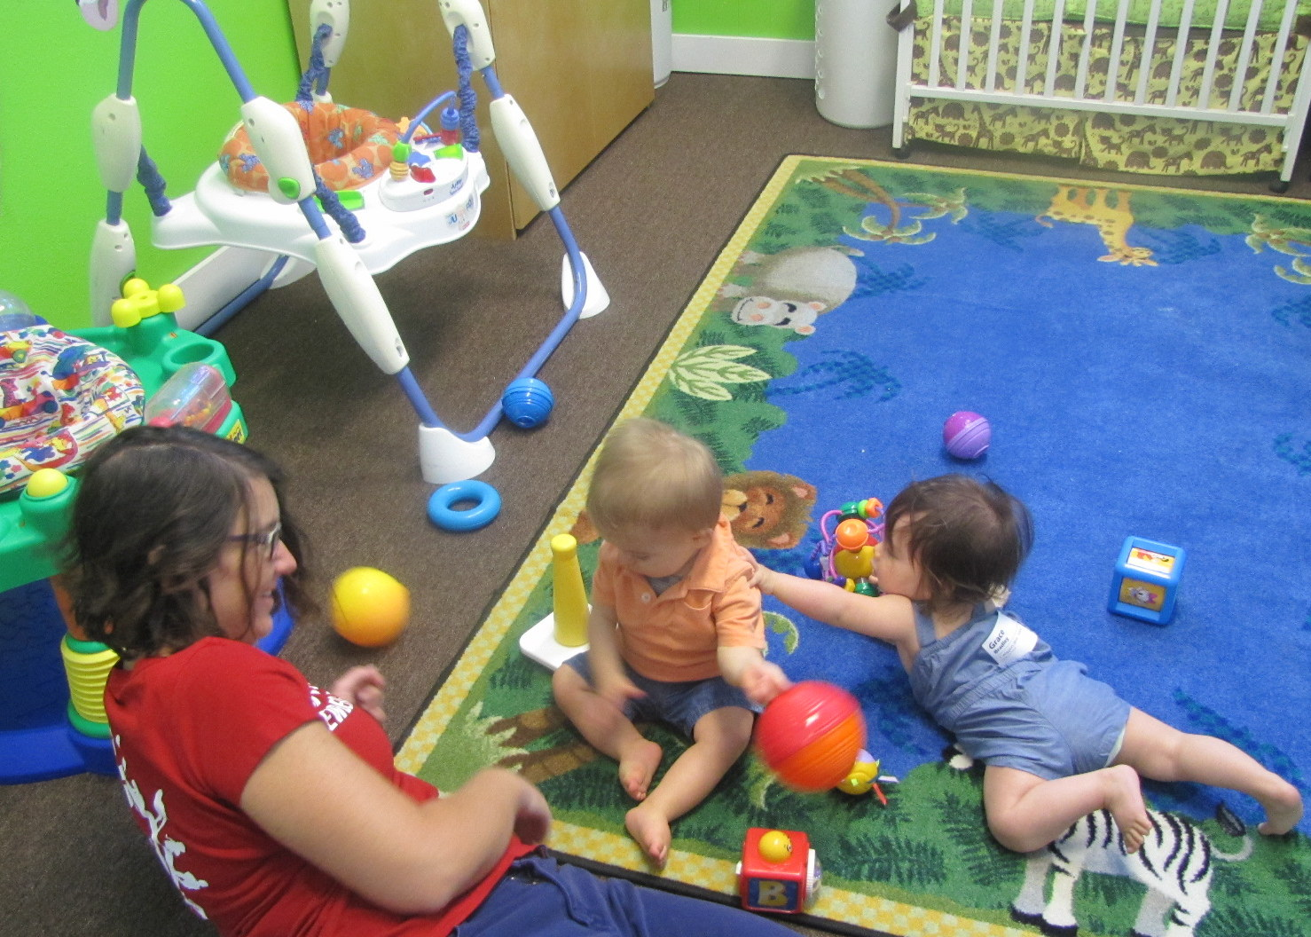
goals and routine: nursery
DISCOVER
Ages 0-24 months
ROUTINE:
WIGGLERS (birth to walking)
Leader huddle
Check-in
Play time
Pray out loud for baby
Teach “words” to baby
Play and sing worship songs
Diaper changing
Possible feeding or nap

WADDLERS (walking to 24 months)
Leader huddle
Check-in & Play time & clean up
Snacks, Lesson, & Worship:
Bible story/worship/prayer
Diapers & ready for check-out
GOALS
- Provide a great environment
- Teach foundational truths to babies/toddlers
- Pray powerful prayers over each baby and toddler
- Build relationships with parents

LOVE GOD: We teach babies/toddlers that the Bible is special & God loves us.
LOVE PEOPLE: We teach gentleness and basic manners toward one another.
SERVE THE WORLD: We teach that we all clean up our toys.

leader descriptions: nursery
MINISTRY LEADER
TEACHER “TO-DO’S”

DURING THE WEEK
- Respond to Planning Center email
- Communicate if you can’t serve on your day
- PRAY!

BEFORE SERVICE
- Huddle Time/Location
- Where things are in the nursery
- Where supplies are located
- Curriculum Explained
- Location of Emergency #’s
- Check-in Process
- Allergies
- Room Ratios

DURING SERVICE
- What we expect for your specific position
- Changing Diapers
- Feeding
- When to call parents
- Discipline
- Touch & 2 leader rule
- In case of Evacuation
- In case of Lockdown
- In case of Missing Child

AFTER SERVICE
- Check-out Procedures
- Cleaning up
- Taking a good post-service nap
- Build your team and communicate. Manage the monthly schedule, sending our scheduling emails and following up. Keep lists accurate and up to date.
- Communicate with the children’s pastor about any needs for your room or any questions about your ministry.
- Train new leaders, train existing leaders, etc. Build relationships with your teachers.
- Foster relationships with parents and their babies.
LEAD TEACHERS
- Arrive 25 minutes before service.
- Lead the huddle.
- You’re in charge of this the room; work with the Assistant and Junior Teachers providing them with the direction needed.
- Interact and play with the babies, encouraging and loving them. Be loving and kind with the parents, building relationship with them.

ASSISTANT & JUNIOR TEACHERS
- Arrive 25 minutes before service for the huddle.
- Report to the Lead Teacher in charge of your room.
- Follow the Lead Teacher, helping them work through the curriculum & activities provided.
- You’re the relational giant of the room. Your biggest job is to interact and play with the babies, encouraging and loving them. Be loving and kind with the parents, building relationship with them.

goals and routine: twos & threes
DISCOVER
2 AND 3 YEAR OLDS

ROUTINE:
Leader huddle 5 min
Check-in & Play time 15 min
Clean up 5 min
Circle Time 10 min
Lesson Time 10 min
Craft & Snack 15 min

GOALS
- Provide a great environment for toddlers to learn about God’s love
- Give kids a loving, hands-on experience
- Build relationships with parents

LOVE GOD: We help toddlers know and love the basic story of God.
LOVE PEOPLE: We show that loving others means sharing and saying nice things.
SERVE THE WORLD: We teach that serving means cleaning up our toys.

leader descriptions: twos & threes
MINISTRY LEADER
TEACHER “TO-DO’S”

DURING THE WEEK
- Respond to Planning Center email
- Communicate if you can’t serve on your day
- PRAY!

BEFORE SERVICE
- Huddle Time/Location
- Where things are in the nursery
- Where supplies are located
- Curriculum Explained
- Location of Emergency #’s
- Check-in Process
- Allergies
- Room Ratios

DURING SERVICE
- Our goals
- What we expect for your specific position
- When to call parents
- Discipline
- Touch & 2 leader rule
- In case of Evacuation
- In case of Lockdown
- In case of Missing Child

AFTER SERVICE
- Check-out Procedures
- Cleaning up
- Taking a good post-service nap
- Build your team and communicate. Manage the monthly schedule, sending our scheduling emails and following up. Keep lists accurate and up to date.
- Communicate with the children’s pastor about any needs for your room or any questions about your ministry.
- Train new leaders, train existing leaders, etc. Build relationships with your teachers.
- Foster relationships with parents and their babies.
LEAD TEACHERS
- Arrive 25 minutes before service.
- Report to Teacher Kim. Lead the huddle.
- You’re in charge of this the room; work with the Assistant and Junior Teachers providing them with the direction needed.
- Interact and play with the children, encouraging and loving them. Be loving and kind with the parents, building relationship with them.

ASSISTANT & JUNIOR TEACHERS
- Arrive 25 minutes before service for the huddle.
- Report to the Lead Teacher in charge of your room.
- Follow the Lead Teacher, helping them work through the curriculum & activities provided.
- You’re the relational giant of the room. Your biggest job is to sit with a group of kids and participate in whatever the current activity is, encouraging and loving them.

goals and routine: fours & fives

and kindergarten & 1st Grade
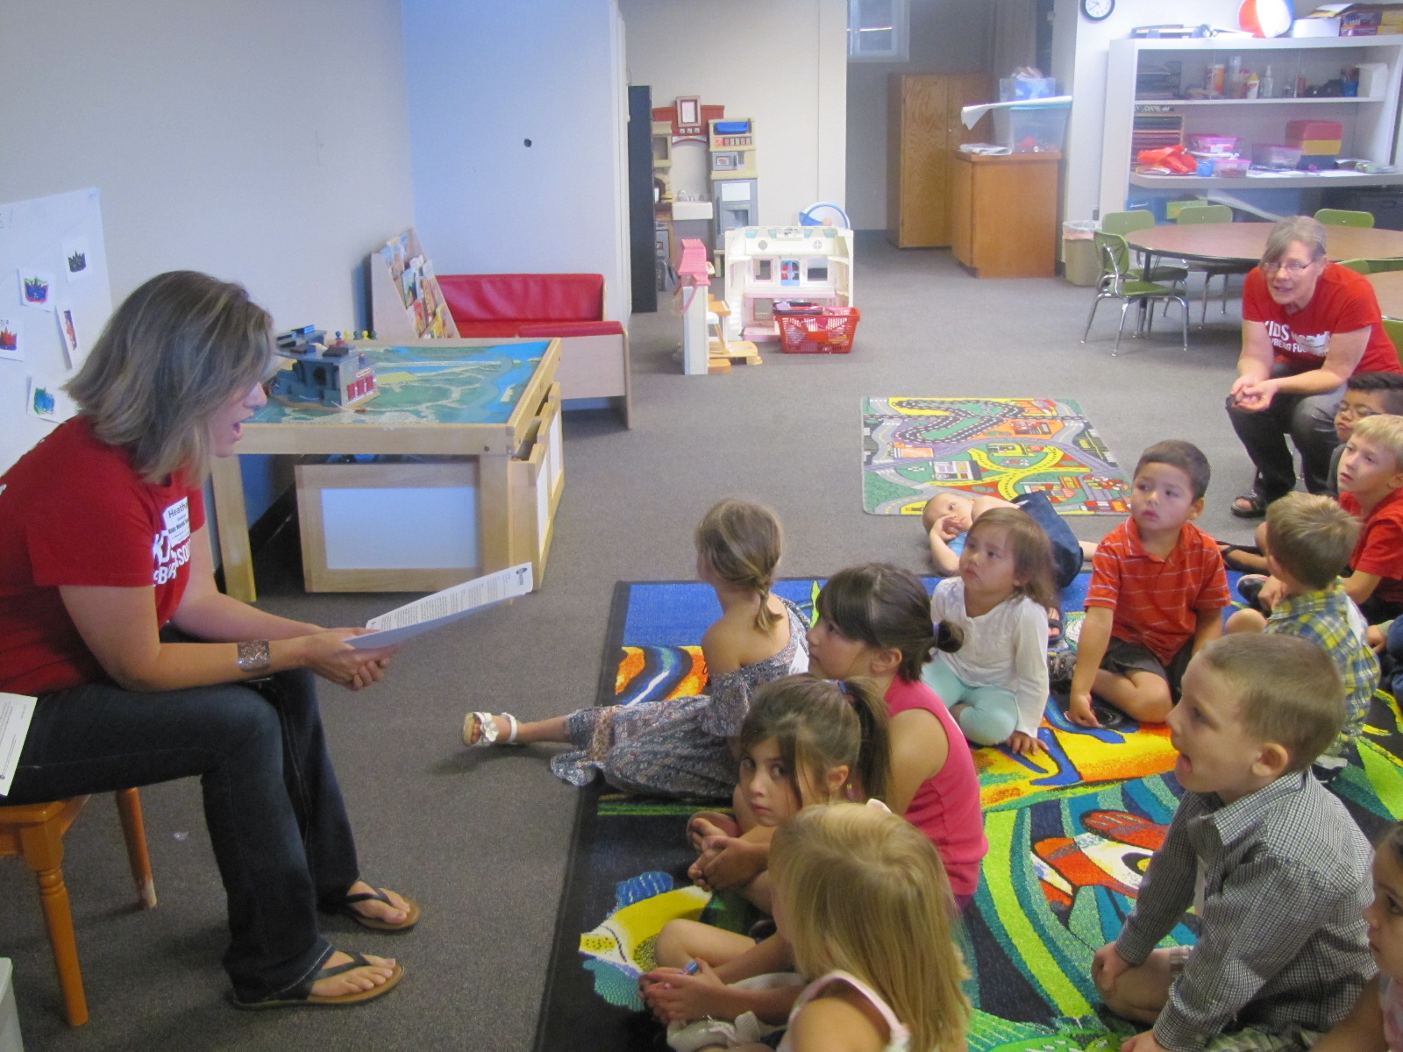
ADVENTURE
4-year-old to Kindergarten

ROUTINE:
Leader huddle 5 min
Check-in & Play time 20 min
Clean up 5 min
Circle time 10 min
Lesson Time 15 min
Craft& Snack 15 min

GOALS
- Provide a great environment as they learn the basics of the Bible and Jesus.
- Give kids a loving, hands-on experience.
- Build relationships with parents.

LOVE GOD: We help preschoolers and kindergarteners know and love God and His Big Story.
LOVE PEOPLE: We show that loving others means sharing and saying nice things.
SERVE THE WORLD: We teach that serving means cleaning up our toys, praying for other, and showing kindness to those around them.

leader descriptions: 4s, 5s, k & 1st
MINISTRY LEADER
TEACHER “TO-DO’S”

DURING THE WEEK
- Respond to Planning Center email
- Communicate if you can’t serve on your day
- Download lesson and prepare.
- PRAY!

BEFORE SERVICE
- Huddle Time/Location
- Where things are in the classroom
- Where supplies are located
- Curriculum/Schedule Explained
- Location of Emergency #’s
- Check-in Process
- Allergies
- Room Ratios

DURING SERVICE
- Our goals
- What we expect for your specific position
- When to call parents
- Discipline
- Touch & 2 leader rule
- In case of Evacuation
- In case of Lockdown
- In case of Missing Child

AFTER SERVICE
- Check-out Procedures
- Cleaning up
- Taking a good post-service nap
- Build your team and communicate. Manage the monthly schedule, sending our scheduling emails and following up. Keep lists accurate and up to date.
- Communicate with the children’s pastor about any needs for your room or any questions about your ministry.
- Train new leaders, train existing leaders, etc. Build relationships with your teachers.
- Foster relationships with parents and their children.
LEAD TEACHERS
- Arrive 25 minutes before service.
- Lead the huddle.
- You’re in charge of this the room; work with the Assistant and Junior Teachers providing them with the direction needed.
- Interact and play with the children, encouraging and loving them. Be loving and kind with the parents, building relationship with them.

ASSISTANT & JUNIOR TEACHERS
- Arrive 25 minutes before service for the huddle.
- Report to the Lead Teacher in charge of your room.
- Follow the Lead Teacher, helping them work through the curriculum & activities provided.
- You’re the relational giant of the room. Your biggest job is to sit with a group of kids and participate in whatever the current activity is, encouraging and loving them.

goals and routine: 2nd through 5th grade
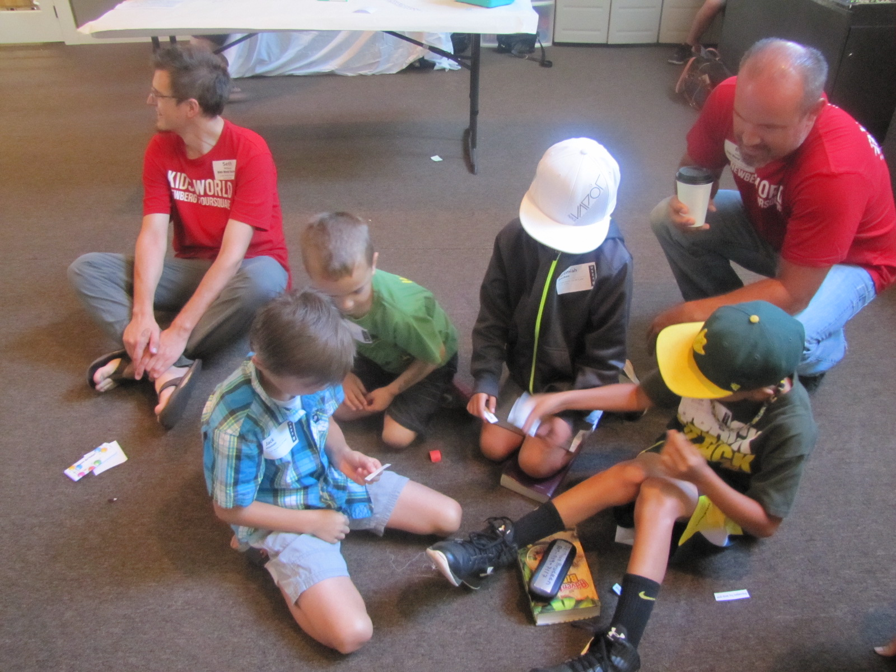
ADVENTURE
Grades 2-5
ROUTINE:
Leader huddle & Check-in 15 min
Game 10 min
Large Group 25 min
Worship 15 min
Small Group 15 min
Review & play 5 min

GOALS
- Provide a great environment make friends and worship God
- Give kids a loving, loads-of-fun experience
- Provide a solid knowledge of the Bible, guiding kids into a personal faith and walk with Jesus
- Build relationships with parents

LOVE GOD: We encourage kids to live like Jesus.
LOVE PEOPLE: We teach that loving others means being like Jesus to them.
SERVE THE WORLD: We help kids start to work out their faith.

leader descriptions: 2nd through 5th grade
MINISTRY LEADER
TEACHER “TO-DO’S”

DURING THE WEEK
- Respond to Planning Center email
- Communicate if you can’t serve on your day
- Download lesson and prepare.
- PRAY!

BEFORE SERVICE
- Huddle Time/Location
- Where things are in the classroom
- Where supplies are located
- Curriculum/Schedule Explained
- Location of Emergency #’s
- Check-in Process
- Allergies
- Room Ratios

DURING SERVICE
- Our goals
- What we expect for your specific position
- When to call parents
- Discipline
- Touch & 2 leader rule
- In case of Evacuation
- In case of Lockdown
- In case of Missing Child

AFTER SERVICE
- Check-out Procedures
- Cleaning up
- Taking a good post-service nap
- Build your team and communicate. Manage the monthly schedule, sending our scheduling emails and following up. Keep lists accurate and up to date.
- Communicate with the children’s pastor about any needs for your room or any questions about your ministry.
- Train new leaders, train existing leaders, etc. Build relationships with your teachers.
- Foster relationships with parents and their children.
LARGE GROUP TEACHERS
- Arrive 25 minutes before service.
- Lead and teach the large group time.
- Report to the children’s pastor. Lead the huddle.
- You’re in charge of the Small Group Teachers providing them with the direction needed.
- Interact and play with the children, encouraging and loving them. Build relationship with parents.

SMALL GROUP TEACHERS
- Arrive 25 minutes before service for the huddle.
- Check-in with the Large Group Teacher.
- In Large Group time, follow the Large Group Teacher, helping them work through the curriculum & activities provided.
- Be prepared to lead small group discussion and other activities.
- You’re the relational giant of the room. Your biggest job is to sit with a group of kids and participate in whatever the current activity is, encouraging and loving them.

goals and routine: Kids World teams
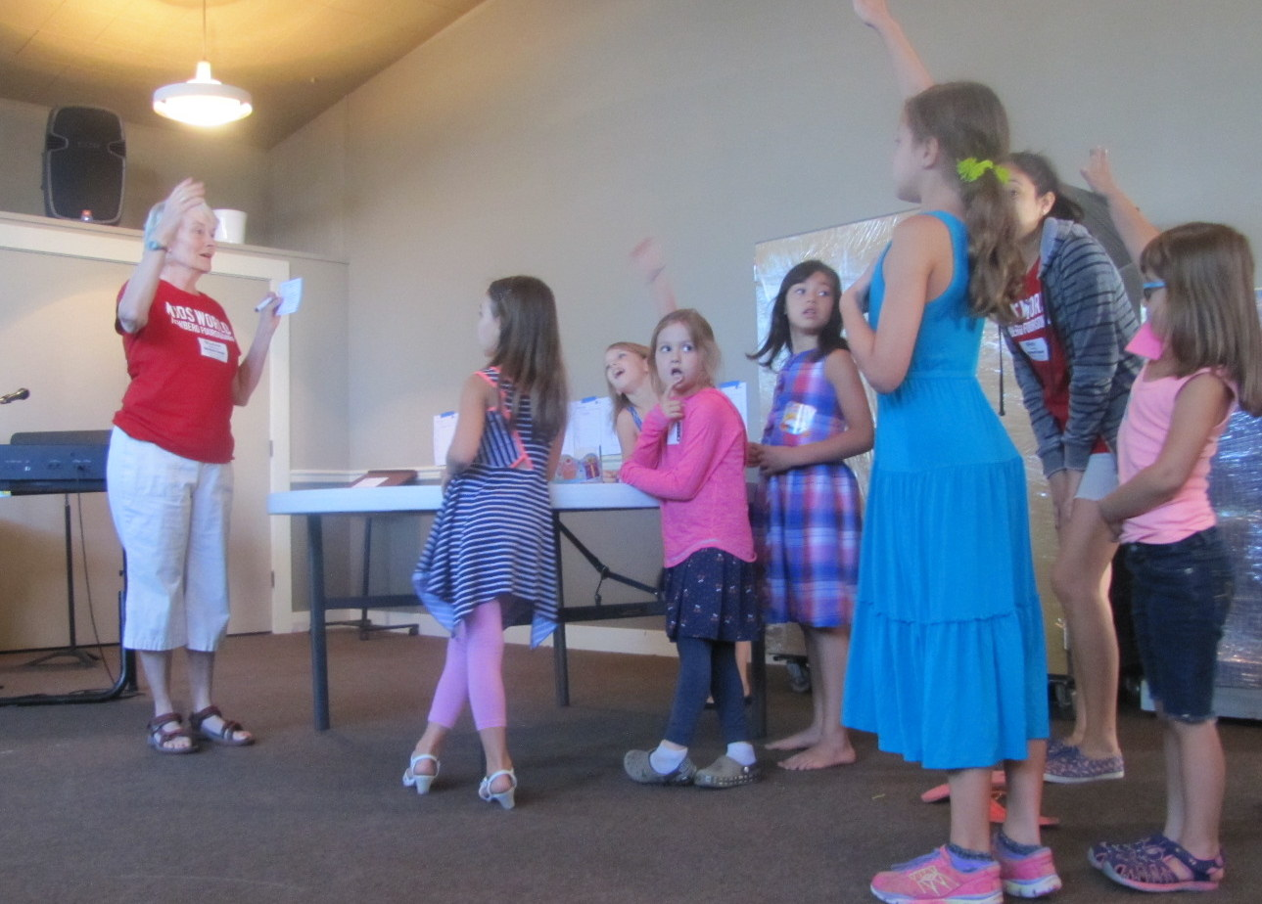
ROUTINE:
Leader huddle & Check-in 15 min
Game 10 min
Large Group 25 min
Worship 15 min
Small Group 15 min
Review & play 5 min

LARGE GROUP TEACHERS, WORSHIP LEADERS, WELCOME TEAM, MEDIA

- Arrive 25 minutes before service for the huddle. Check-in and get name tag.
- Prepare the room for worship and service.
- Welcome Team: use Planning Center Online Check-Ins.
- Large Group Teachers: Creatively tell the story, making it understandable for a young audience. Direct the small group teachers during the service.
- Worship Leaders: Engage the kids with 2-3 songs that help them sing praises to Jesus.

descriptions: Kids World teams
WORSHIP TEAM
“TO-DO’S”

DURING THE WEEK
- Respond to Planning Center email
- Communicate if you can’t serve on your day
- Download lesson and prepare.
- PRAY!

BEFORE SERVICE
- Huddle Time/Location
- Where things are in the classroom
- Where supplies are located
- Location of Emergency #’s
- Check-in Process
- Allergies
- Room Ratios

DURING SERVICE
- Our goals
- What we expect for your specific position
- When to call parents
- Discipline
- Touch & 2 leader rule
- In case of Evacuation
- In case of Lockdown
- In case of Missing Child

AFTER SERVICE
- Check-out Procedures
- Cleaning up
- Taking a good post-service nap
- LEADER: Build team, send scheduling emails & follow up, create worship set, set practice date.
- TEAM: Practice songs the week before you’re scheduled and go to the practice.
- Prepare a meaningful worship experience.
- Arrive on time Sunday morning for practice with the team.
- Prayerfully lead worship. Engage the kids with 2-3 songs that help them sing praises to Jesus.
- Be an example of worship and lead the kids, stretching them to praise Jesus. Also help with other tasks that are needed when you're not on stage.
- Clean up area before leaving
CHECK IN / HOST / WELCOME TEAM
- Arrive 25 minutes before service for the huddle.
- Make everyone feel welcome, greeting everyone.
- Help kids get checked in quickly; helping with “self-check” stations as needed.
- Help parents and kids who have various needs during the service (like early pick up).
- Check "pick-up tags" as parents pick up kids. Ensure that every kid leaves with the right adult.
LARGE GROUP TEACHERS
- Connect with the children’s pastor the week before – let her know what you’ll need for your lesson/activities
- Arrive 25 minutes before service for prayer and prep.
- Creatively tell the story, providing direction to the small group teachers.
- Help kids have a fun, meaningful experience.
MEDIA / PROPRESENTER
- Arrive 25 minutes before service begins. Connect with Large Group Teacher and Worship leader when you arrive. Make sure that sound and visual needs are ready.
- Be focused! Keep your attention on whoever is leading and have slides and media cues ready as they lead.
- Be a ninja. Avoid actions that draw attention away from the leader and to yourself.

leadership: possible positions
JOBS WORKING DIRECTLY WITH KIDS AND FAMILIES
ROOM LEADERS: Work in a specific class with a specific age group and oversee that one class. It requires some confidence to oversee a room and lead kids and some Room Assistants.
ROOM ASSISTANTS: This is our most "relational" position in Kids World. Room Assistants don't have to do a lot of curriculum management. They hang with kids and help Room Leaders take care of the bigger picture.
JOBS WORKING BEHIND THE SCENES
AREA LEADERS: Help out by overseeing multiple classrooms at once. In this role, you are helping make sure each Room Leader has whatever he/she needs. You are like an assistant to the Ministry Leader of that area, helping them lead the area so they can focus on leader interviews and other tasks.
SECURITY: We need to keep our children safe, and we feel like security is heightened when a small group of men and women are focused on that for the entire service. You'll have a radio and will simply roam around, making sure our kids are safe and weirdoes are not.
CREATIVE POSITION: We need storytellers, worship leaders, and large group activity leaders. These people are engaging a group of kids, but it's a lot different than being in a classroom for an entire hour. We also need seasonal decorating for classrooms, organizing, printing, sending out cards, and follow up.
NEW FAMILY INFO CENTER: We have multiple check-in rooms that need to be staffed with one person to help people who have questions about the check-in screens. It's a great position because you get to help families make sure their first experience is a good one. And, it ends 30 minutes into the service! Also, we need people to write occasional card to children and their families.

leadership: the commitment
THANK YOU!
Thanks for checking out our guide for becoming a teacher in Kids World! We know this is a high commitment. But, we believe with a high commitment comes a high reward. We get to love on kids and families while having a ton of fun. Here is a breakdown of the commitment we ask each volunteer to make:

TIME COMMITMENT
Being a Kids World volunteer is a WEEKLY to MONTHLY commitment.
If you can't do at least monthly, you can join the sub list. We will call on you to fill in missing spots when we are short leaders.
The amount of time you serve will be less than 2 HOURS on a Sunday.
There are one or two TRAININGS each year.
TOTAL: From 2 HOURS up per month (plus trainings)

leadership: joining the team
Joining the team is pretty easy and quick, but it is a process. We want to make sure the right people are serving our young ones. It also ensures you're serving in a spot that fits your personality and gifts.

STEP 1 READ this entire guide
STEP 2 FILL OUT and turn in ABC forms:
Are you an ADULT and signing up to serve with children for the FIRST TIME at our church?
- Application / Adult Volunteer
- Background Check
- Code of Conduct
Are you UNDER 18 years old and signing up to serve with children for the FIRST TIME at our church? (no background check needed)
- Application / Junior Volunteer
- Code of Conduct

STEP 3 We will send you a “welcome” email from PLANNING CENTER ONLINE (PCO). Follow the directions to set up your account. You will receive emails (and texts if you’d like) from your Ministry Leaders through PCO. It’s our main communication with our teams.
STEP 4 ORIENTATION/TRAINING You will walk through an orientation on your first Sunday with your area leader or an experienced teacher. The ongoing trainings will help keep you up to date on any changes and provide connection with your ministry team.

Thanks for checking out our guide! We hope it has helped you see what we're all about. We hope to hear from you soon!
NOTE: If you are currently serving in Kids World, we do NOT need any forms from you. We will contact you when your background check is about to expire so we can keep you current. But refer to this guide to keep you up to date on changes in Kids World. You’re a rock star!

notes

notes

Kids World: application - Adults
You are asked to enter into a commitment with the Kids World leadership to make this ministry a priority. By signing below, you are stating you have read this entire guide and are committing to the following:
- I will embody the values of a dynamic member of Red Hills Church and will follow the leadership of the Kids World leadership team, including:
  - Being active in growing in my relationship with Jesus
  - Strive to live a godly, "above reproach" lifestyle
  - Faithfully attending a Sunday worship gathering
  - Giving and steward my resources in a God honoring way
- I understand I am responsible as a teacher/leader in my specific area to:
  - Respond to Planning Center requests as soon as possible and be prepared
  - Not gossip about other leaders, kids, or families. If I have issues, I'll go directly to my area leader or director
  - Not tell parents about issues with their kid(s), but instead tell my area leader or director
  - Be on time. If I'm late, I'll communicate to my ministry leader or Teacher Kim.
  - Focus on the kids while I am serving.
- I will never be alone with a child.
- I will attend the training(s) or watch training video online.
- I will do everything I can to give families a great experience and interact in a positive and personal way.
Please indicate which gathering and how often you are committing to serve: 8:00 9:30 11:00  Kids World Events
Weekly Semi-monthly Monthly Sub list

Name (Printed): _________________________________________________________________
Signature: ______________________________________________________________________
CONTACT INFO:
EMAIL__________________________________________ PHONE: ___________________________
AGE LEVEL PREFERNCE:
 Nursery/Wigglers (0-10 mos) Twos & Threes Kindergarten & 1st Grade
 Nursery/Waddlers (11-24 mos.) Fours & Fives Elementary 2nd - 5th Grade
I CAN HELP WITH… Check-Ins Planning/Prep Crafts 2nd-5th Grade only: Sound Engineer Media/ProPresenter Worship/Motions Team Worship/Vocals Worship/Instrument __________________________
PERSONAL INFORMATION
If you prefer, you may discuss your answers to the following questions in person rather than answering them on this application. Answering yes, or leaving the question unanswered, will not automatically disqualify you as an applicant for volunteer work with our children.

Do you have any physical, mental, or emotional conditions that would prevent you from performing certain types of activities related to working with children or youth? Yes No
If yes, please explain:

Is there any circumstance or pattern in your life which would make it inappropriate for you to serve with children or youth, or compromise the integrity of our church? Yes No
If yes, please explain:

CHRISTIAN COMMITMENT AND CHURCH BACKGROUND
Please describe your current relationship with God and the history of your Christian commitment:

How long have you consistently attended Red Hills Church?
What church did you previously attend? How long?
Is there a person from your former church that we may contact? Yes No
Name Phone

REFERENCES
If you are 18 or over, please provide the following information for three people who are over 18 years of age and are able to provide a reference supporting your integrity in relation to working with children, your character and your personal Christian commitment:

Name | Years Known | Address | Phone – Day/Night
D –
N –
D –
N –
D –
N –

The information contained in this form is correct to the best of my knowledge. I authorize any reference or churches listed on this form to give any information (including opinions) that they may have regarding my character and fitness for work with children. I release all such references from any liability for furnishing such evaluations to you, providing they do so in good faith and without malice. I waive any right that I may have to inspect references provided on my behalf. I am striving to live a Holy Spirit-led life and agree to set a Christ-like example while working with the children and/or youth of Red Hills Church.

Signature of Applicant Date

Kids World: application - Junior
You are asked to enter into a commitment with the Kids World leadership to make this ministry a priority. By signing below, you are stating you have read this entire guide and are committing to the following:
- I will embody the values of a dynamic member of Red Hills Church and will follow the leadership of the Kids World leadership team, including:
  - Being active in growing in my relationship with Jesus
  - Strive to live a godly, "above reproach" lifestyle
  - Faithfully attending a Sunday worship gathering
  - Giving and steward my resources in a God honoring way
- I understand I am responsible as volunteer in my specific area to:
  - Respond to Planning Center requests as soon as possible and be prepared
  - Not gossip about other leaders, kids, or families. If I have issues, I'll go directly to my area leader or director
  - Not tell parents about issues with their kid(s), but instead tell my area leader or director
  - Be on time. If I'm late, I'll communicate to my ministry leader or Teacher Kim.
  - Focus on the kids while I am serving.
- I will never be alone with a child.
- I will attend the training(s) or watch training video online.
- I will do everything I can to give families a great experience and interact in a positive and personal way.
Please indicate which gathering and how often you are committing to serve: 8:00 9:30 11:00  Kids World Events
Weekly Semi-monthly Monthly Sub list

Name (Printed): _________________________________________________________________
Applicant’s Signature:____________________________________________________________________
APPLICANT’S CONTACT INFO (if applicable)
EMAIL__________________________________________ PHONE: ___________________________
AGE LEVEL PREFERNCE:
 Nursery/Wigglers (0-10 mos) Twos & Threes Elementary 1st/2nd/3rd
 Nursery/Waddlers (11-24 mos.) Pre+K Elementary 4th/5th
I CAN HELP WITH… Check-Ins Planning/Prep Crafts 2nd-5th Grade only Sound Engineer Media/ProPresenter Worship/Motions Team Worship/Vocals Worship/Instrument __________________________

Red Hills Church
Children’s Ministry
JUNIOR VOLUNTEER

A Junior Volunteer is someone under the age of 18 that helps out in Children’s Ministry at Red Hills Church. We believe that you don’t have to be an adult to minister to people – it can start at any age if you know and love Jesus! Thank you for volunteering to serve our kids and share the love of Jesus with them.

Please tell the story of how you became a Christian: ______________________________________________________________________________________________________________________________________________________________________________________________________________________________________________________________________________________________________________________________________________________________________________________________________________________________________________
________________________________________________________________________________________________________________________________________________________________________________________________________________________________________________________________________________________________________________________________________________________

Our Commitment to you: We will help you learn how to serve, and lead, in Children’s Ministry. We’ll help you learn how to share God’s love and His Word with children while you continue to grow in your relationship with Jesus.

Parent’s Commitment: I will support my child in this area of service and ministry, and will do my part to help him/her fulfill this commitment.

Parent’s Signature: ________________________________________________ Date:_________________

Parent Information

Parent’s Name: _________________________________________________________________________

Email Address: ________________________________________ Phone Number: ___________________

To help with communicating and scheduling via email and phone, please check ONE of the following: (Please note: Emailing through Planning Center Online is our primary way of communication.)

 My information is the best way to communicate with my child (for younger children).
 Use BOTH my child’s and my information to communicate with us (for semi-independent teens).
 Only use my child’s contact info for communication (for very responsible teens).

Code of Conduct
adapted from The Foursquare Church Child and Youth Protection Manual

We are committed to creating a safe and nurturing environment that fosters spiritual, emotional, and physical health for all children who participate in our ministries. We are also committed to protecting the staff members and volunteers from unwarranted accusations. To that end, all staff members/volunteers who work with our children must abide by our Code of Conduct.

Staff Members and Volunteers of The Foursquare Church will:
- Complete the Kids World Commitment Form, background check form, and Code of Conduct.
- Take constructive correction with a good attitude knowing that Red Hills Church values children and that Children's Ministry staff has the children's best interest at heart.
- Pray every week for my class/area of ministry and the children at Red Hills Church.
- Willingly and enthusiastically participate in activities.
- Minister the love of Jesus to all children and to other Children's Ministry volunteers.
- Be ready to serve in area of ministry 25 minutes prior to service time to prepare and pray.
- Utilize Planning Center Online as a tool to communicate availability to area Team Leader: Accepting teaching dates and blocking out dates unable to serve.
- Treat children with respect and fairness at all times, regardless of race, gender, age, or religion.
- Respond with Christian love and understanding in all situations.
- Act as a positive role model for children by maintaining an attitude of respect, loyalty, patience, courtesy, and maturity.
- Dress appropriately and avoid wearing provocative and/or revealing clothing. Be easily identifiable while volunteering by wearing Kids World shirt and a Check-In station name tag.
- Agree with the discipline procedure and will follow it in the classroom.
- Read, understand, and will follow the Child Abuse Prevention Policy.
- Agree to approach the Children's Ministry Overseer with any questions or concerns about a child or area of ministry.
- Engage only in appropriate displays of affection.
- Refrain from inappropriate physical interactions.
- Refrain from using inappropriate corrective measures.
- Refrain from swearing or telling offensive or vulgar jokes.
- Avoid involving children in inappropriately burdensome or disturbing problems or issues.
- Refrain from sharing or keeping secrets with children.
- Not abuse alcohol or drugs.
- Refrain from discussing sexual encounters in the presence of children.
- Not have or view sexually explicit materials, including any type or pornography.
- Refrain from staring at or commenting on a child's body.

- Refrain from perpetrating any kind of abuse upon any child; this includes, but is not limited to, the following:
- Verbal abuse: degrading, threatening, cursing
- Physical abuse: hitting, shaking, slapping, unnecessary restraints
- Sexual abuse: inappropriate touching, exposing oneself, sexually-oriented conversations
- Emotional abuse: shaming, humiliating, cruelty
- Neglect: withholding or denying food, water, clothing, shelter, medical care, freedom of movement, or failure to protect.
Abuse of any kind will not be tolerated. Allegations of abuse may result in immediate removal of the staff member/volunteer from duties, and may result in permanent dismissal at the sole discretion of The Foursquare Church. The Foursquare Church will fully cooperate with authorities if allegations of abuse are made and investigated.
- Immediately report concerns or complaints, including suspicions of abuse, about a Red Hills Church staff member, volunteer, or child to the Children's Ministry Overseer and to a member of the ministerial staff.

As an applicant for a volunteer position with access to children at Red Hills Church and its ministries I (print name) __________________________________________ have read, understand, and agree to abide by the policies set forth in this manual. I further agree to abide by all policies, procedures and rules of Red Hills Church regarding children and as otherwise deemed applicable to me. I further understand that any violation of this Team Agreement may result in my immediate and potentially permanent dismissal.

I declare that I will not abuse (physically, verbally, sexually, or emotionally) or neglect any child or adult; and that I have never been convicted of abuse of, indecency with, or injury to a child or adult.

__________________________ ______________________________ _______________
Applicant Name (print) Signature of Applicant Date

Background Check Form

→ Please fill out completely, sign and date. Thank you!
______________________________________________________________________________
Consumer, Investigative, and Direct Reports Authorization, Disclosure and Release
Name |  |  | Social Security no. |  | Date of Birth (mm/dd/yyyy)
Street Address |  | City |  | State |  | Zip Code
Diver’s License no. | State of Issuance | Any other names used (maiden name, etc.)
By signing below, I hereby voluntarily authorize International Church of the Foursquare Gospel
d/b/a Newberg Foursquare Church ID #31340 / dba Red Hills Church (legal name and code number of church, school, camp) (“Foursquare”) to obtain “consumer reports” and “investigative consumer reports” about me from a “consumer reporting agency,” and reports Foursquare may obtain directly, and to consider these reports when making decisions regarding my employment/volunteer position or potential position with Foursquare. The nature and scope of these reports are as follows. They may contain information on my character, general reputation, personal characteristics, and mode of living. They may also include, among other things, checks, records and/or information regarding: my criminal convictions (including, without limit, court, sex offender, incarceration and DMV records), social security number, current and prior employer(s)/supervisor(s) and/or references I provided, coworkers, neighbors, friends, associates or acquaintances, and verification of college degrees and professional licenses or certifications.

I understand that I have rights under the Fair Credit Reporting Act (and the California Investigative Consumer
Reporting Agencies Act and other California law for California residents, the Government Data Practices for
Minnesota residents, the Credit Services Organization Act for Oklahoma residents, the equivalent New York FCRA for New York residents, and the equivalent Maine FCRA for Maine residents) including the rights discussed in the separate disclosure statement(s) provided to me.

I authorize any governmental entity, law enforcement agency, institution, information service bureau, school, employer, supervisor, reference, or other person contacted by Church Volunteer Central (or other selected agency) or Foursquare, or their agents or volunteers, to furnish the information described herein. I release and discharge from liability all persons, agencies, and entities providing the above information or reports about me to Church Volunteer Central (or other selected agency) and/or Foursquare. To the fullest extent permitted by law, I further release and discharge Foursquare and Church Volunteer Central (or other selected agency), and their agents, employees and volunteers, from any claims, damages, losses, liabilities, costs and/or expense arising from the retrieving and/or reporting of said information, including any consumer report or investigative consumer report.

I acknowledge a copy or telephonic facsimile of this document shall be valid as the original. If I am presently a
resident of Maine or New York, I have reviewed the additional state law disclosure information attached.
Signature | Date
If you would like a copy of any investigative consumer report sent to you at your address listed above, please check
the box below.
□ Yes, I would like to receive a copy of any investigative consumer report which may be obtained on me by a consumer reporting agency.
□ If you would like to receive a copy via email, please provide your email address.
______________________________________________________________________________
Your date of birth is requested to verify the information obtained is about you and not someone with the same or a similar name. It will not be used for employment purposes.
